# Caremark.com – Digital Order Release from Member or Indefinite Hold Job Aid (Integrated Pharmacy Experience)

Information

Member or Indefinite Hold Order Release (Signed In /Authenticated User)

Digital Order Release From Hold (DOR) – In Process / Payment Problem

Guest Experience - Member or Indefinite Hold Order Release – Email and SMS/Text

Med D Ship Consent as Guest

Med D Ship Consent Email Alert

Related Documents

**Description:** Provides the process for members to **Release from Hold** eligible prescriptions in the authenticated user experience (member logged in) as well as email and SMS/text alerts with a link to re-order prescriptions on member or indefinite hold.

|  |
| --- |
| Information |

**Prescription orders are routinely placed “on hold” for the following reasons:**

* A member requests that an order be placed on hold.
* There are payment issues (payment method problem, high copay, etc.).
* The Med D ship consent not provided for auto refill orders.

**Note:**  Screen capture may not match actual scenario for this process. Some clients may not enlist in specific web features. This job aid is intended as a guide only.

Top of the Document

|  |
| --- |
| Member or Indefinite Hold Order Release (Signed In /Authenticated User) |

 **08/16/2024 – The redesigned Digital Order Release (DOR) enhancements have been rolled out for all members.**

Redesigned user experience for Mail Order on Hold prescriptions that are placed on hold due to **Participant Hold**, **Ship Consent**, and **Payment Hold**.

* **Participant On Hold sub status:** This order was canceled because you didn’t approve the shipment. If you want this prescription, you can reorder it from your prescriptions page.
* **Payment On Hold sub status**: This order was canceled because there's a problem with your payment method. If you'd still like to get it, you can reorder it from your prescriptions page and change your payment method.
* **Ship Consent On Hold sub status**: This order was canceled because you didn't approve the shipment. If you'd still like to get it, you can reorder it from your prescriptions page.

We are now showing the above order statuses and **displaying a link to the View your prescriptions page**.  Members can then select for refill and go through the normal checkout flow. (Previously, members would through the Digital Order Release flow).

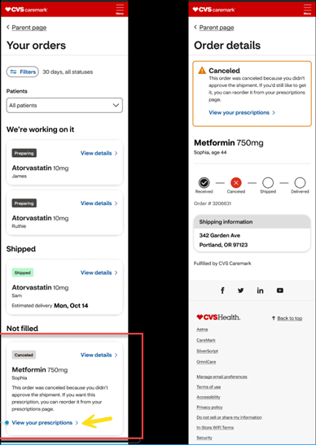

Top of the Document

|  |
| --- |
| Digital Order Release From Hold (DOR) – In Process / Payment Problem |

|  |  |
| --- | --- |
| **Step** | **Action** |
| **1** | Member logs into Caremark.com to manage their Mail Order prescriptions and navigates to the **Your Orders**page.  The Order Details page shows members a full breakdown of an order that is on hold and actions that can be taken to release an order in the Digital Order Release (DOR) self-service flow (for authenticated members only) and includes status of the order and details of the order disruption.  **Payment Hold Example:**   * Click **Change payment method** or **View details**.      * Select **Add Credit/debit/FSA/HSA card** or **Add Bank Account**.      * Confirmation received when payment method successfully added. |

Top of the Document

|  |
| --- |
| Guest Experience - Member or Indefinite Hold Order Release – Email and SMS/Text |

Perform the steps below:

|  |  |  |
| --- | --- | --- |
| **Step** | **Action** | |
| **1** | Members will receive an email or text alert when prescriptions are placed on member or indefinite hold. | |
| **2** | Email or text alert will contain a link to the **guest experience**, which will allow members to re-order prescriptions placed on hold without calling Customer Care.   * Alerts are shown from the Communication History in PeopleSafe and are identified as **DOR** in the alert name. * The order corresponding to the alert can be found by accessing the Caremark.com tab from PeopleSafe and navigating to Order Status to view the order associated with the date of the initial alert.   **Communication History**  **DOR Initial Alert:**    **DOR Reminder Alert:**    **Note:** The guest experience will not require login to an existing account or the creation of a new account. When accessing the link from the alert, members are required to confirm their identity by entering their date of birth.    Reference the table below: | |
| **Step** | **Action** |
| **Order on-hold prescriptions** | Select Rx(s), then click **Continue to review order** OR **Cancel.** |
| **Submit order** | The following must be selected:   * Shipping address * Shipping method * Payment method   The following information is displayed for the order:   * Contact Information * Selected Prescriptions * Account Balance   Select **Submit order** or **Cancel.** |
| **Cancel is selected** | If **Cancel** is selected, the member receives a pop-up to confirm **Yes, I want to leave** or **No, I want to go back**. |

Top of the Document

|  |
| --- |
| Med D Ship Consent as Guest |

Med D members can approve the release an auto-refill shipment using the “**guest experience**”.

* **Note:** The guest experience does not require login or creating an account.

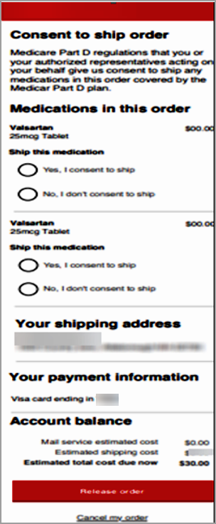

Top of the Document

|  |
| --- |
| Med D Ship Consent Email Alert |

**Note:** Members that are logged into the portal will still be able to provide consent through existing functionality

Updated SCH alerts:

|  |  |
| --- | --- |
| **Alert** | **Example** |
| First |  |
| Second |  |
| Final |  |

Top of the Document

|  |
| --- |
| Related Documents |

**Parent Document:** [CALL 0045 Customer Care Web Support Email Response and Handling](https://policy.corp.cvscaremark.com/pnp/faces/DocRenderer?documentId=CALL-0045)

[CALL 0011 Authenticating Caller](https://policy.corp.cvscaremark.com/pnp/faces/DocRenderer?documentId=CALL-0011)

**Abbreviations/Definitions:** Customer Care Abbreviations, Definitions, and Terms

**Index:** Caremark.com - Work Instruction/Job Aid Index

Top of the Document

Not To Be Reproduced Or Disclosed to Others Without Prior Written Approval

**ELECTRONIC DATA = OFFICIAL VERSION – PAPER COPY – INFORMATIONAL ONLY**